**Inglés 8**

**Quiz evaluativo #1**

ESTUDIANTE: __________________________________ FECHA: __________________

1. Choose the correct form of the present simple affirmative of the verb to be.

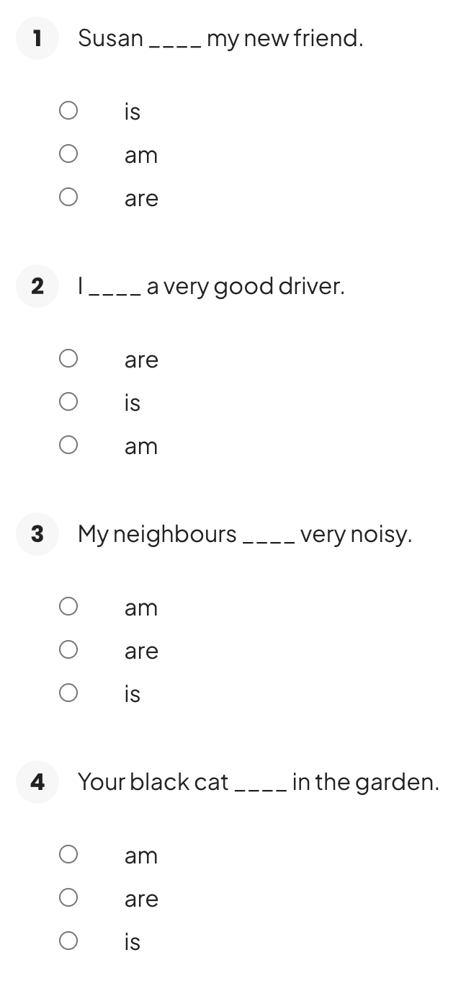 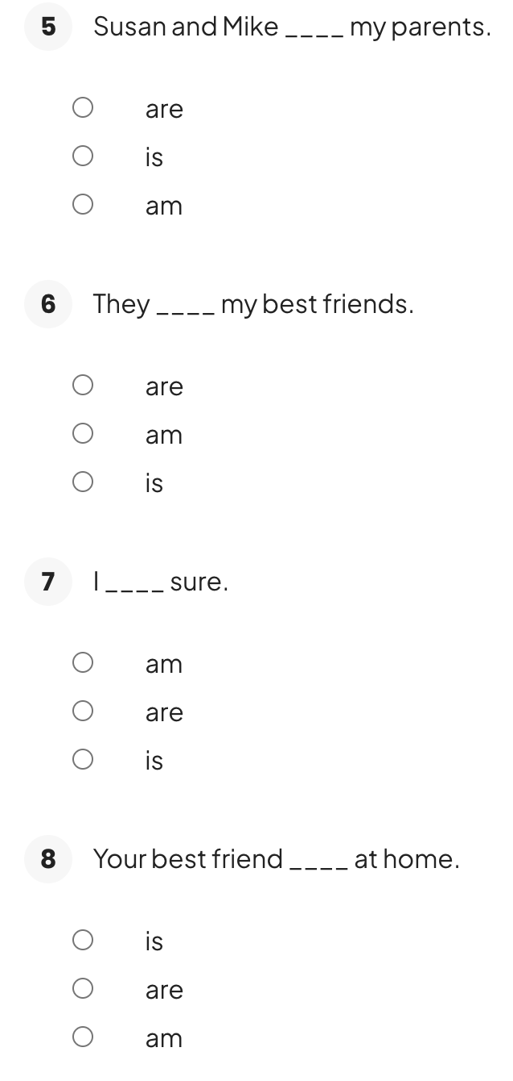

1. Choose the correct answer according to the object pronouns
2. **Who is Kate? Kate is my friend. ____ is a teacher.**

* Her
* He
* She
* His

1. **Who is this man? This is Henry. _____ is my boss.**

* His
* Her
* He
* She

1. **Do you know Tom? Yes, I know _____.**

* she
* he
* her
* him

1. **I don't see them. Do _____ see them?**

* you
* I
* they
* me

1. **We are going to the cinema. Do you want to come with _____?**

* we
* them
* us
* you

1. I love this book! Did you read _____?

* it
* he
* they
* she

1. **Where are Tom and Kate living? _____ live next to my house.**

* She
* They
* He
* We

1. **Where's the cat? _____ is in the garden.**

* It
* Its
* She
* He

1. **It's Mary's birthday today. I called _____ this morning.**

* she
* him
* her
* it

1. **Amy and John are my new friends. I really like _____.**

* they
* them
* him
* her

1. Read the time in English and write the time with numbers.

1.- It’s two o’ clock ______2:00______

2.- It`s three – ten ________________

3. It's four - twenty. ________________

4. It's seven after eight. ________________

5. It's a quarter to seven. ________________

6. It's five to two. ________________

7. It's twenty minutes to nine. _________________

8. It's a quarter past four. _________________

9. It's half past ten.

10. It’s a quarter to four. ________________

1. Write the corresponding time in English under each clock

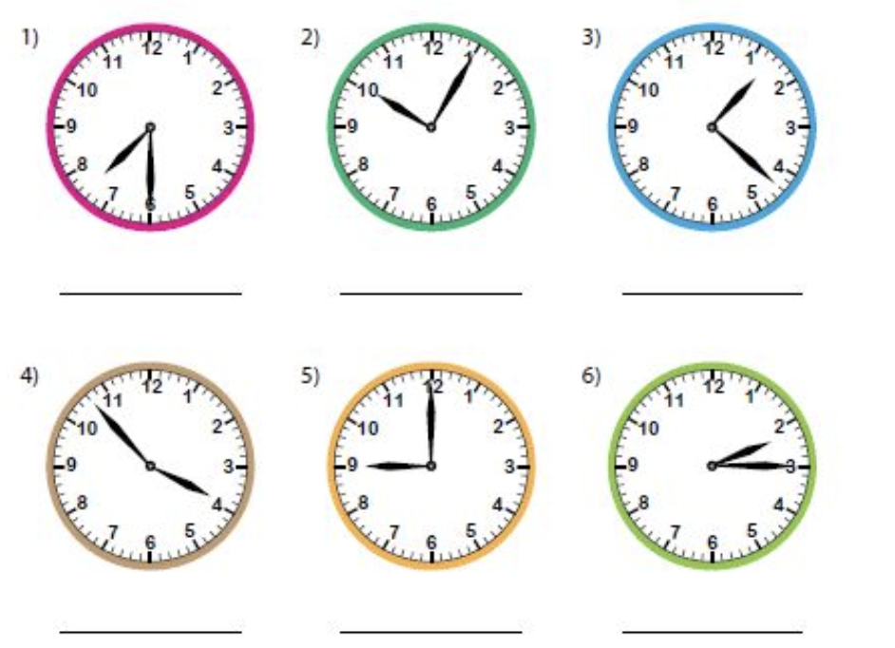

1. Choose the correct answer
2. **____ is my car here.**

* This
* That
* These
* Those

1. **____ are my children over there in the park.**

* This
* That
* These
* Those

1. **____ is my car over there.**

* This
* That
* These
* Those

1. **____ are my children here.**

* This
* That
* These
* Those

1. **____ bike over there is mine.**

* This
* That
* These
* Those

1. 6 de 8Do you know ____ boys over there?

* this
* that
* these
* those

1. **Can I use ____ pencil here?**

* this
* that
* these
* those

1. **I love ____ biscuits here.**

* this
* that
* these
* those

1. Choose the option that best answers the following questions:

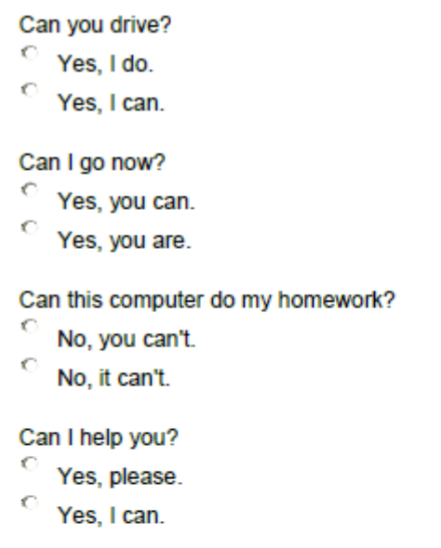 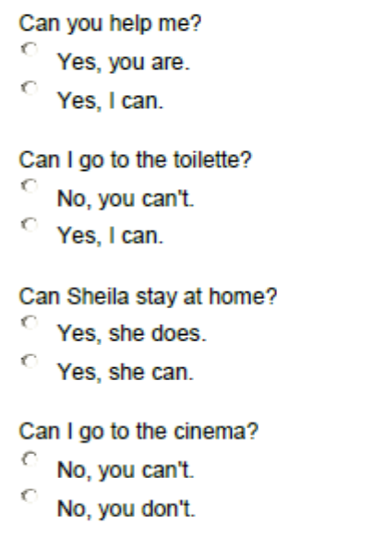

1. Complete the sentences correctly using Can or Can't

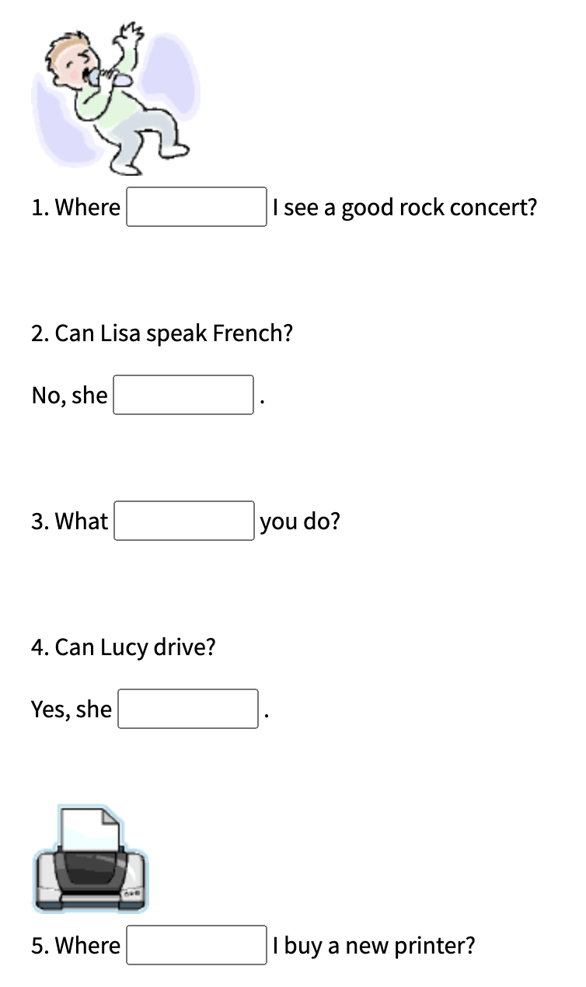 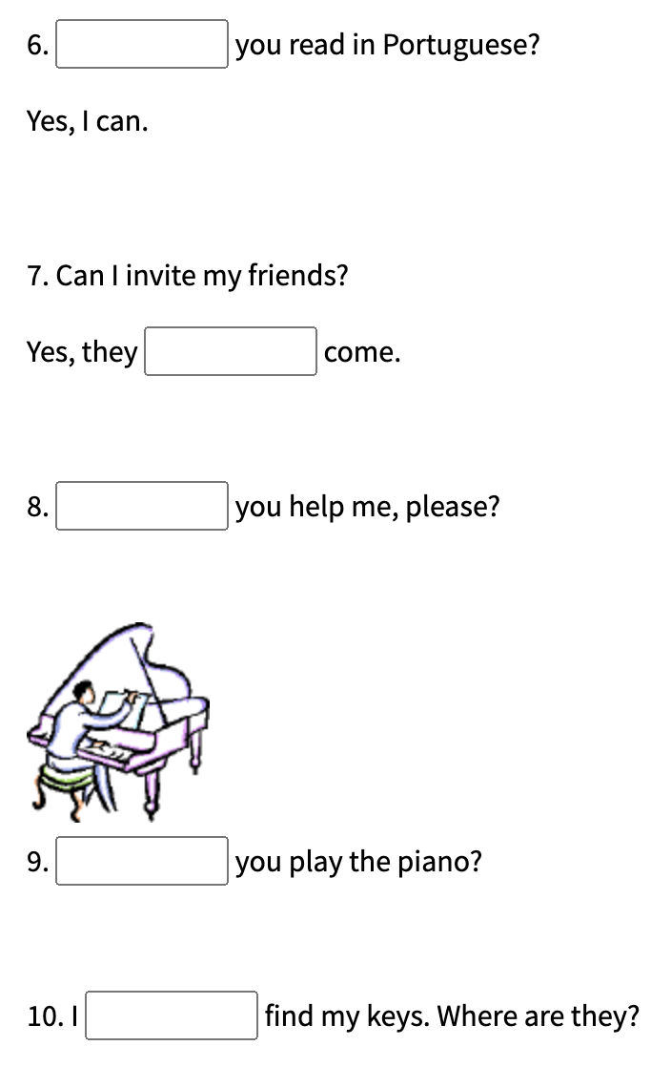

1. Write in English a text in which you narrate your daily routine now. Use Adverbs of frequency ( always, usually, generally, normally, often, frequently, sometimes, ocassionally, seldom, rarely, never).
2. Complete the sentences with the correct form of the comparative of superiority or superlative of the adjectives in parentheses:

1. This phone is (expensive)______________  than the one I bought last year.

2. His house is (big)_________________  in the neighborhood.

3. Today is (cold)_________________  than yesterday.

4. The movie was (good)__________________  than I expected.

5. Her car is (fast)______________________  in the race.

6. His performance was (impressive)________________  among all the candidates.

7. This laptop is (light)___________________  than mine.

8. Her dress is (beautiful)____________________  in the store.

9. Today is (hot)___________________  day of the year.

10. This cake is (delicious)________________________  I've ever tasted.

11. His car is (comfortable)____________________  than mine.

12. Her apartment is (small)_____________________  in the building.

13. The weather is (bad)________________  it was last week.

14. His English is (fluent)__________________  in the class.

15. This hotel is (luxurious)_____________________  in the city.

16. Her cooking is (tasty)_________________  I've ever had.

17. This movie is (interesting) ________________ than the one we watched yesterday.

18. His apartment is (modern)___________________  in the city.

19. Today is (sunny)_____________________  day of the week.

1. Complete the sentences with the verbs in parenthesis. Use the past continuous.

Example 0. The children (play) **were playing** football during the week.

1. It (rain) ……… ……….. hard during the soccer game.

2. I (study) ……… ………. English for five years in London.

3. Mary (be) ……… ……….. always (borrow) ……… ……….. my books.

4. Peter (practise) ………… ……. the guitar before the competition.

5. Susan (drive) ……… ………. when the accident happened.

6. My friends (fight) ………… ……… during the whole night at the club.

}7. Daniela (teach) ……… ……….. language for ten hours.

8. I (try) ……… ………. to get a new job.

9. Jane (plan) ……… ……….. to go to the cinema with her parents.